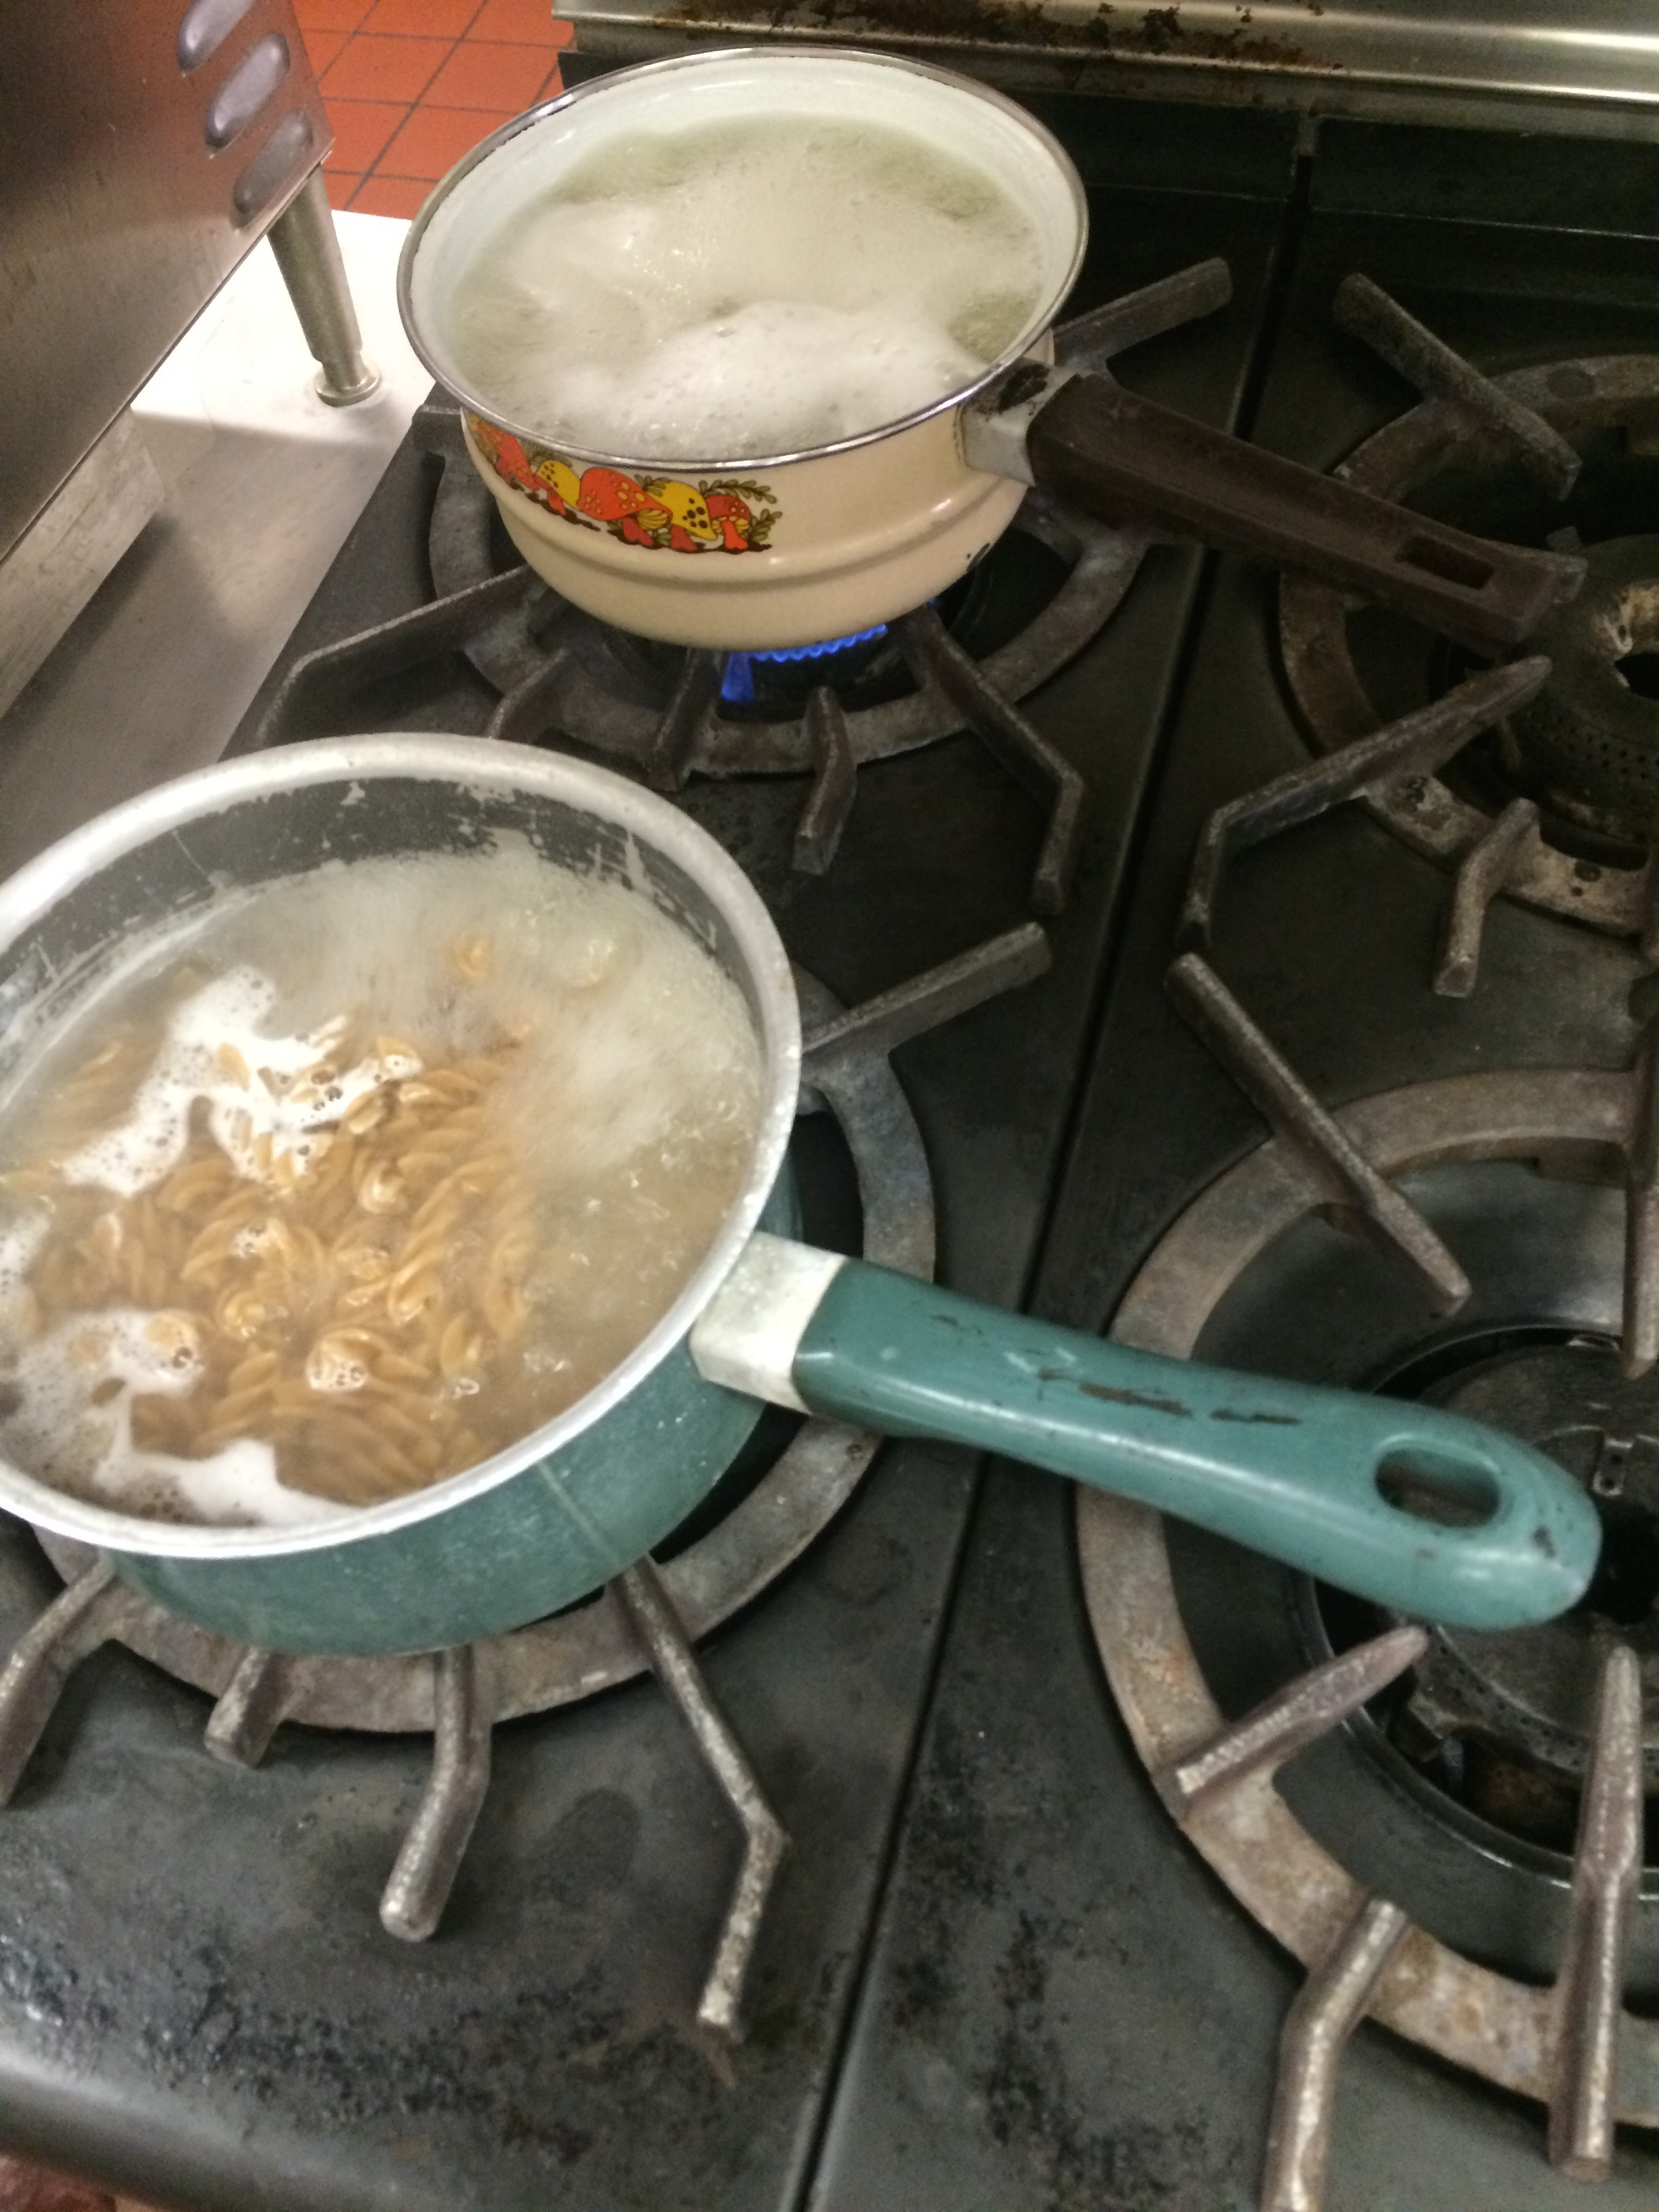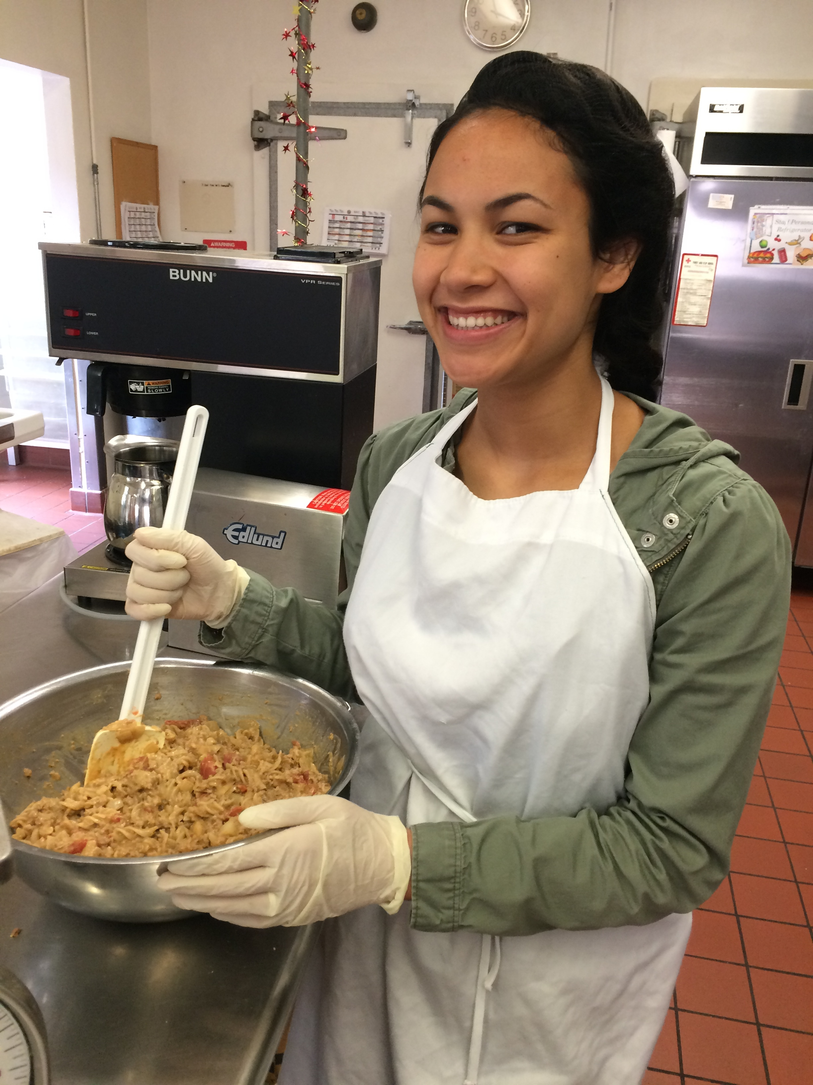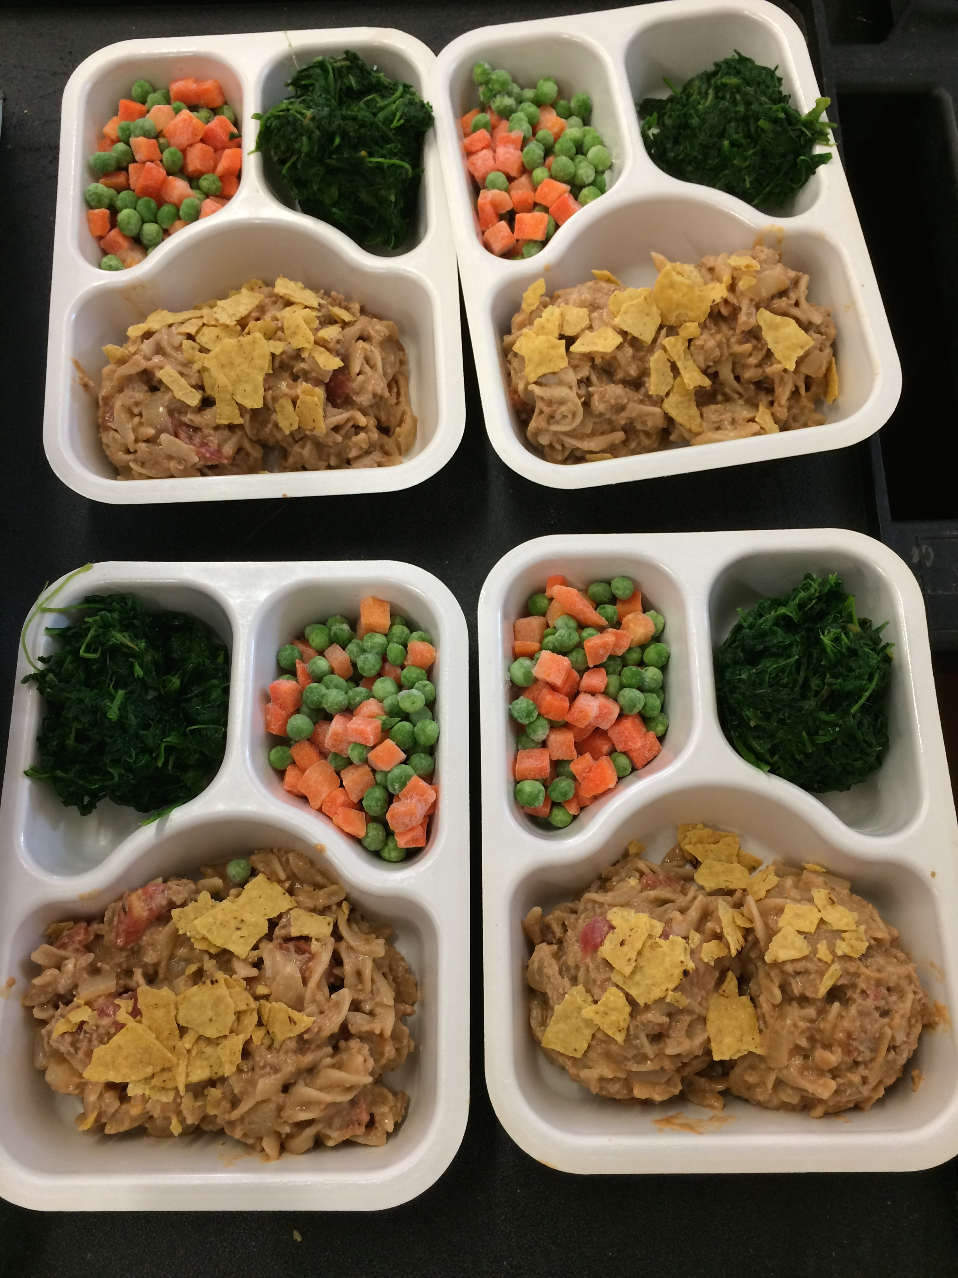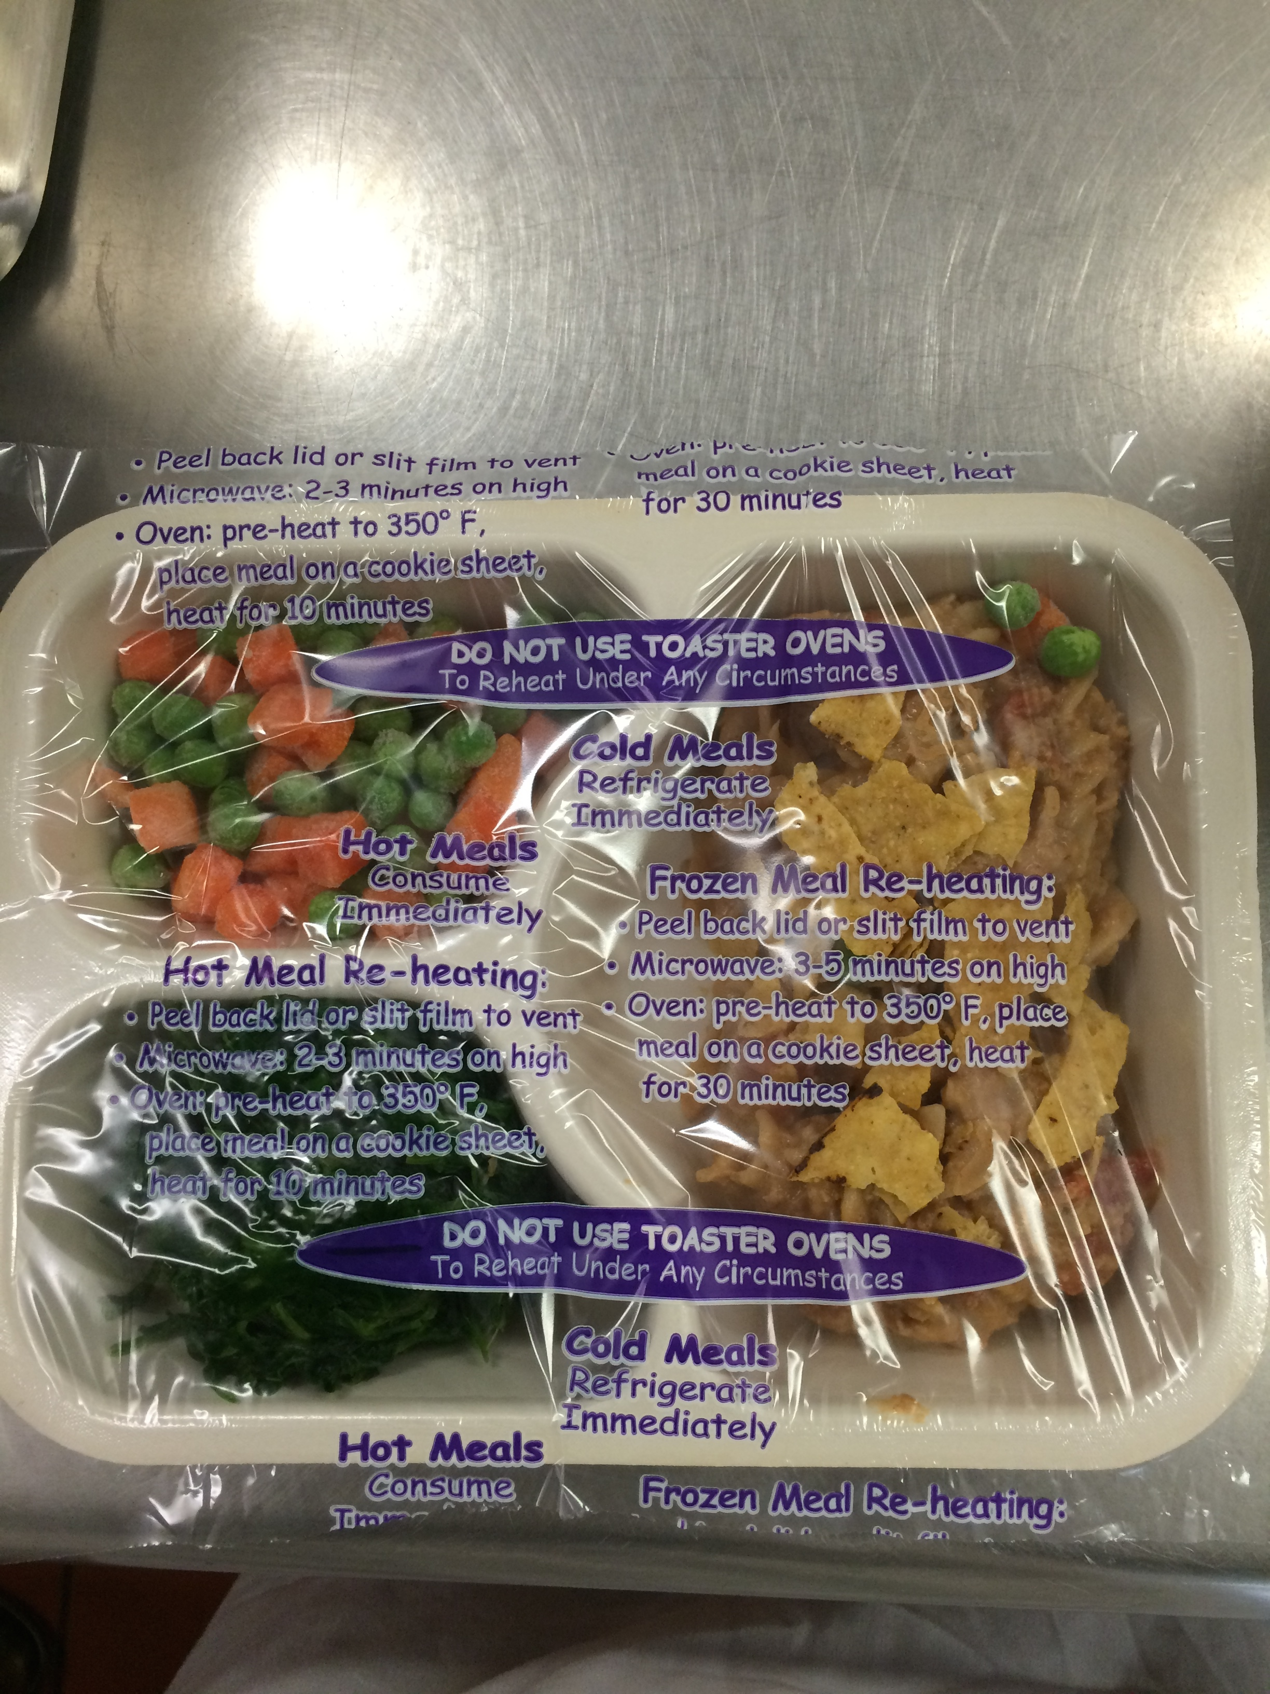

This is what the packaging looked like when the taco pasta was complete! We paired our taco pasta with peas and carrots and spinach and added some crushed tortilla chips as garnish to add vibrant colors to the tray. We used the Oliver Tray Lidder to package the meals.

Overall this was a great experience that allowed us to learn about the time, productivity level, preparation, money, and methods that go into making a standardized recipe. We are very thankful to SNP for allowing us use their facilities and commodities!

