Recipe Standardization Project
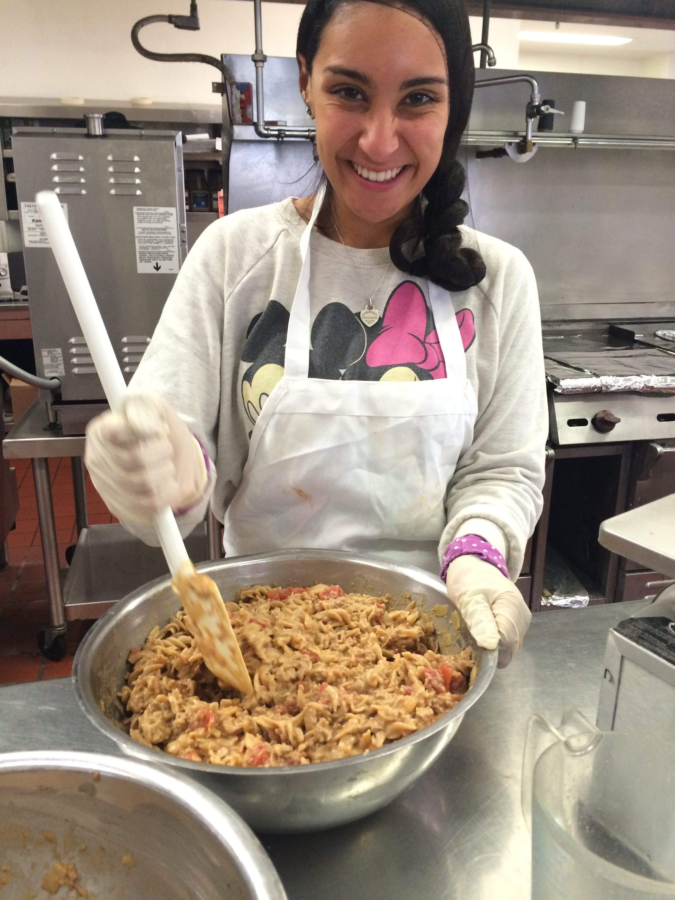
Alyssa Gormaly and I worked on our recipe standardization project at Senior Nutrition Program (SNP). They graciously allowed us to use any extra commodities available to develop a new recipe. We were given whole-wheat pasta, taco meat, and American cheese. After doing a little research we decided to go with a Taco Pasta Recipe. The development of this product is documented below.
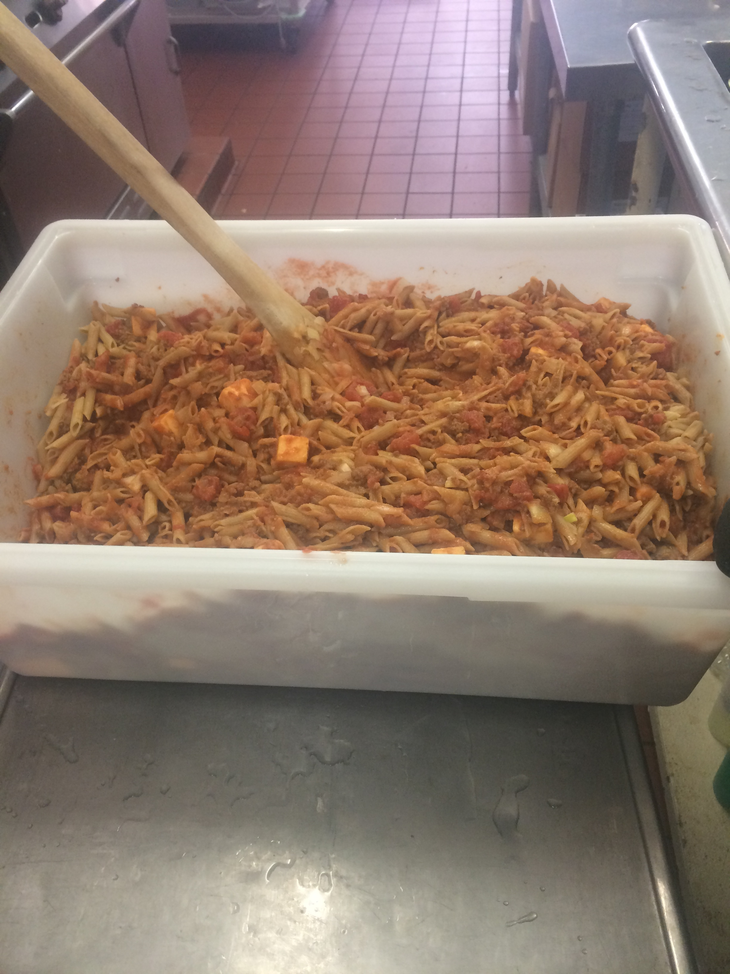
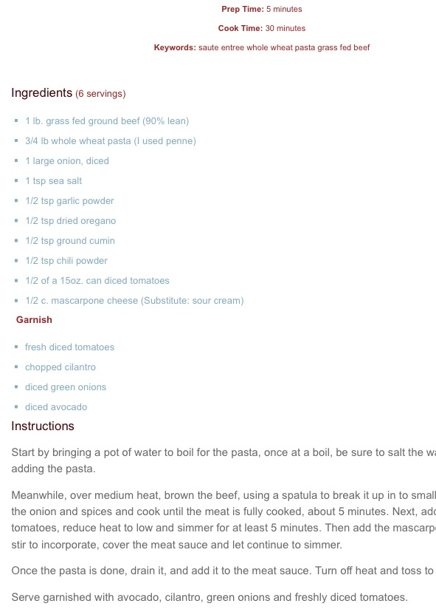

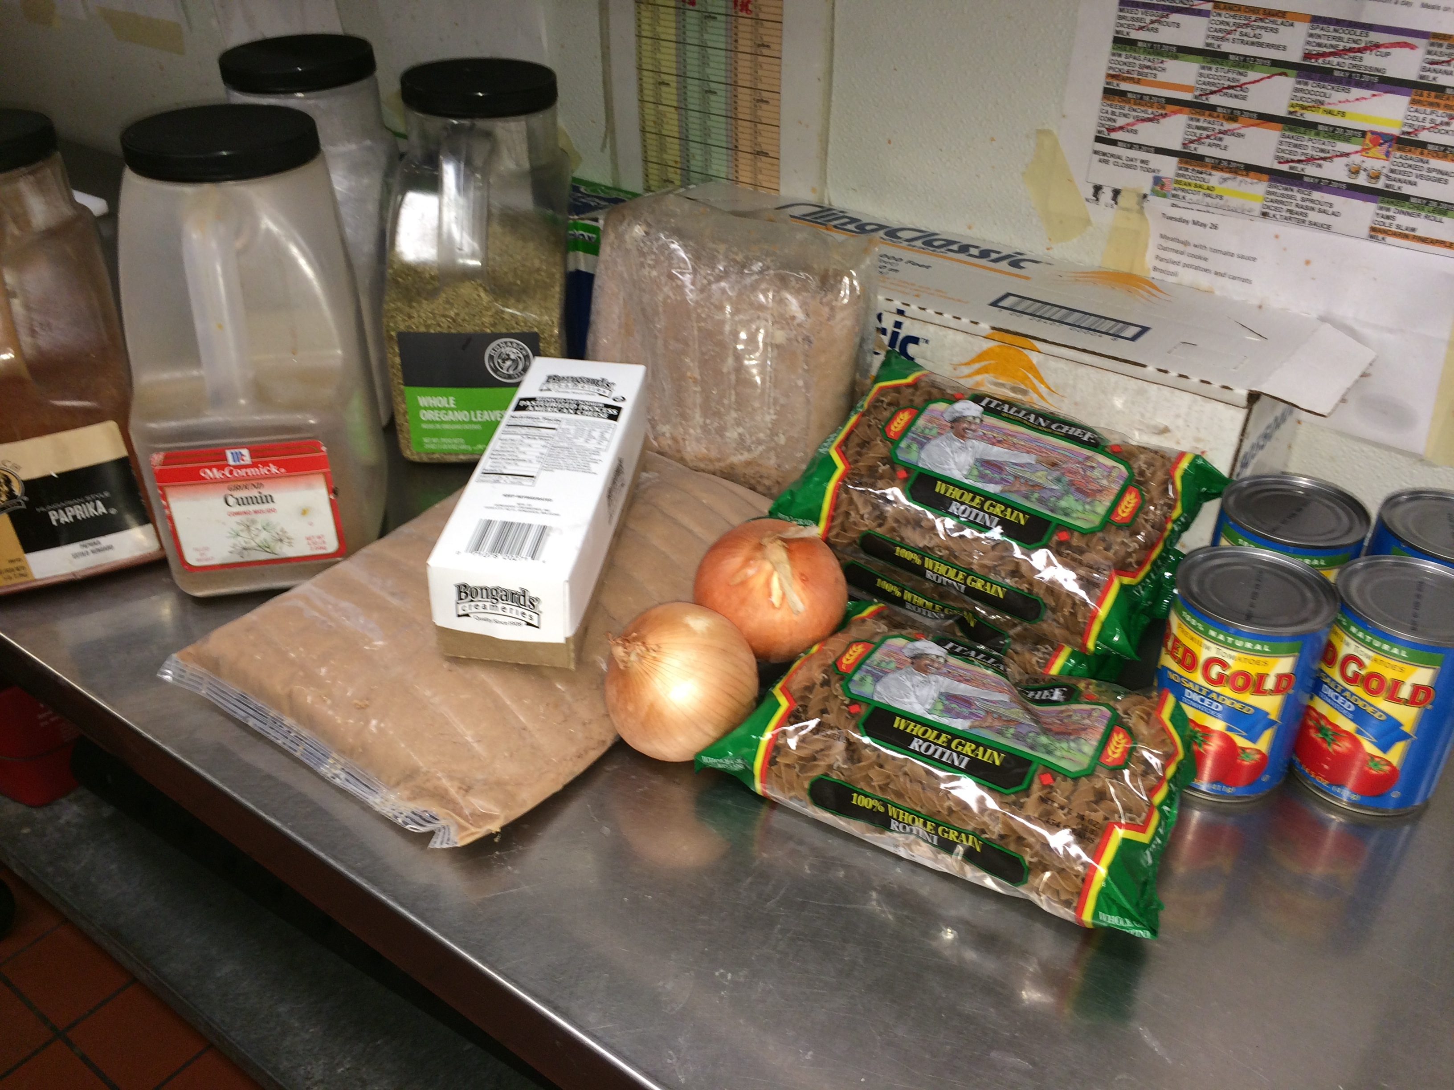

Before we began production, we agreed to substitute American cheese (a SNP commodity) for mascarpone and omitted salt due to a regulation of SNP frozen meals. After preparing the recipe for the first time and seeing that it looked a bit dry, we added ½ of a 15 oz. can of tomato sauce to add wetness to the recipe. The original recipe yield was 6 servings.

