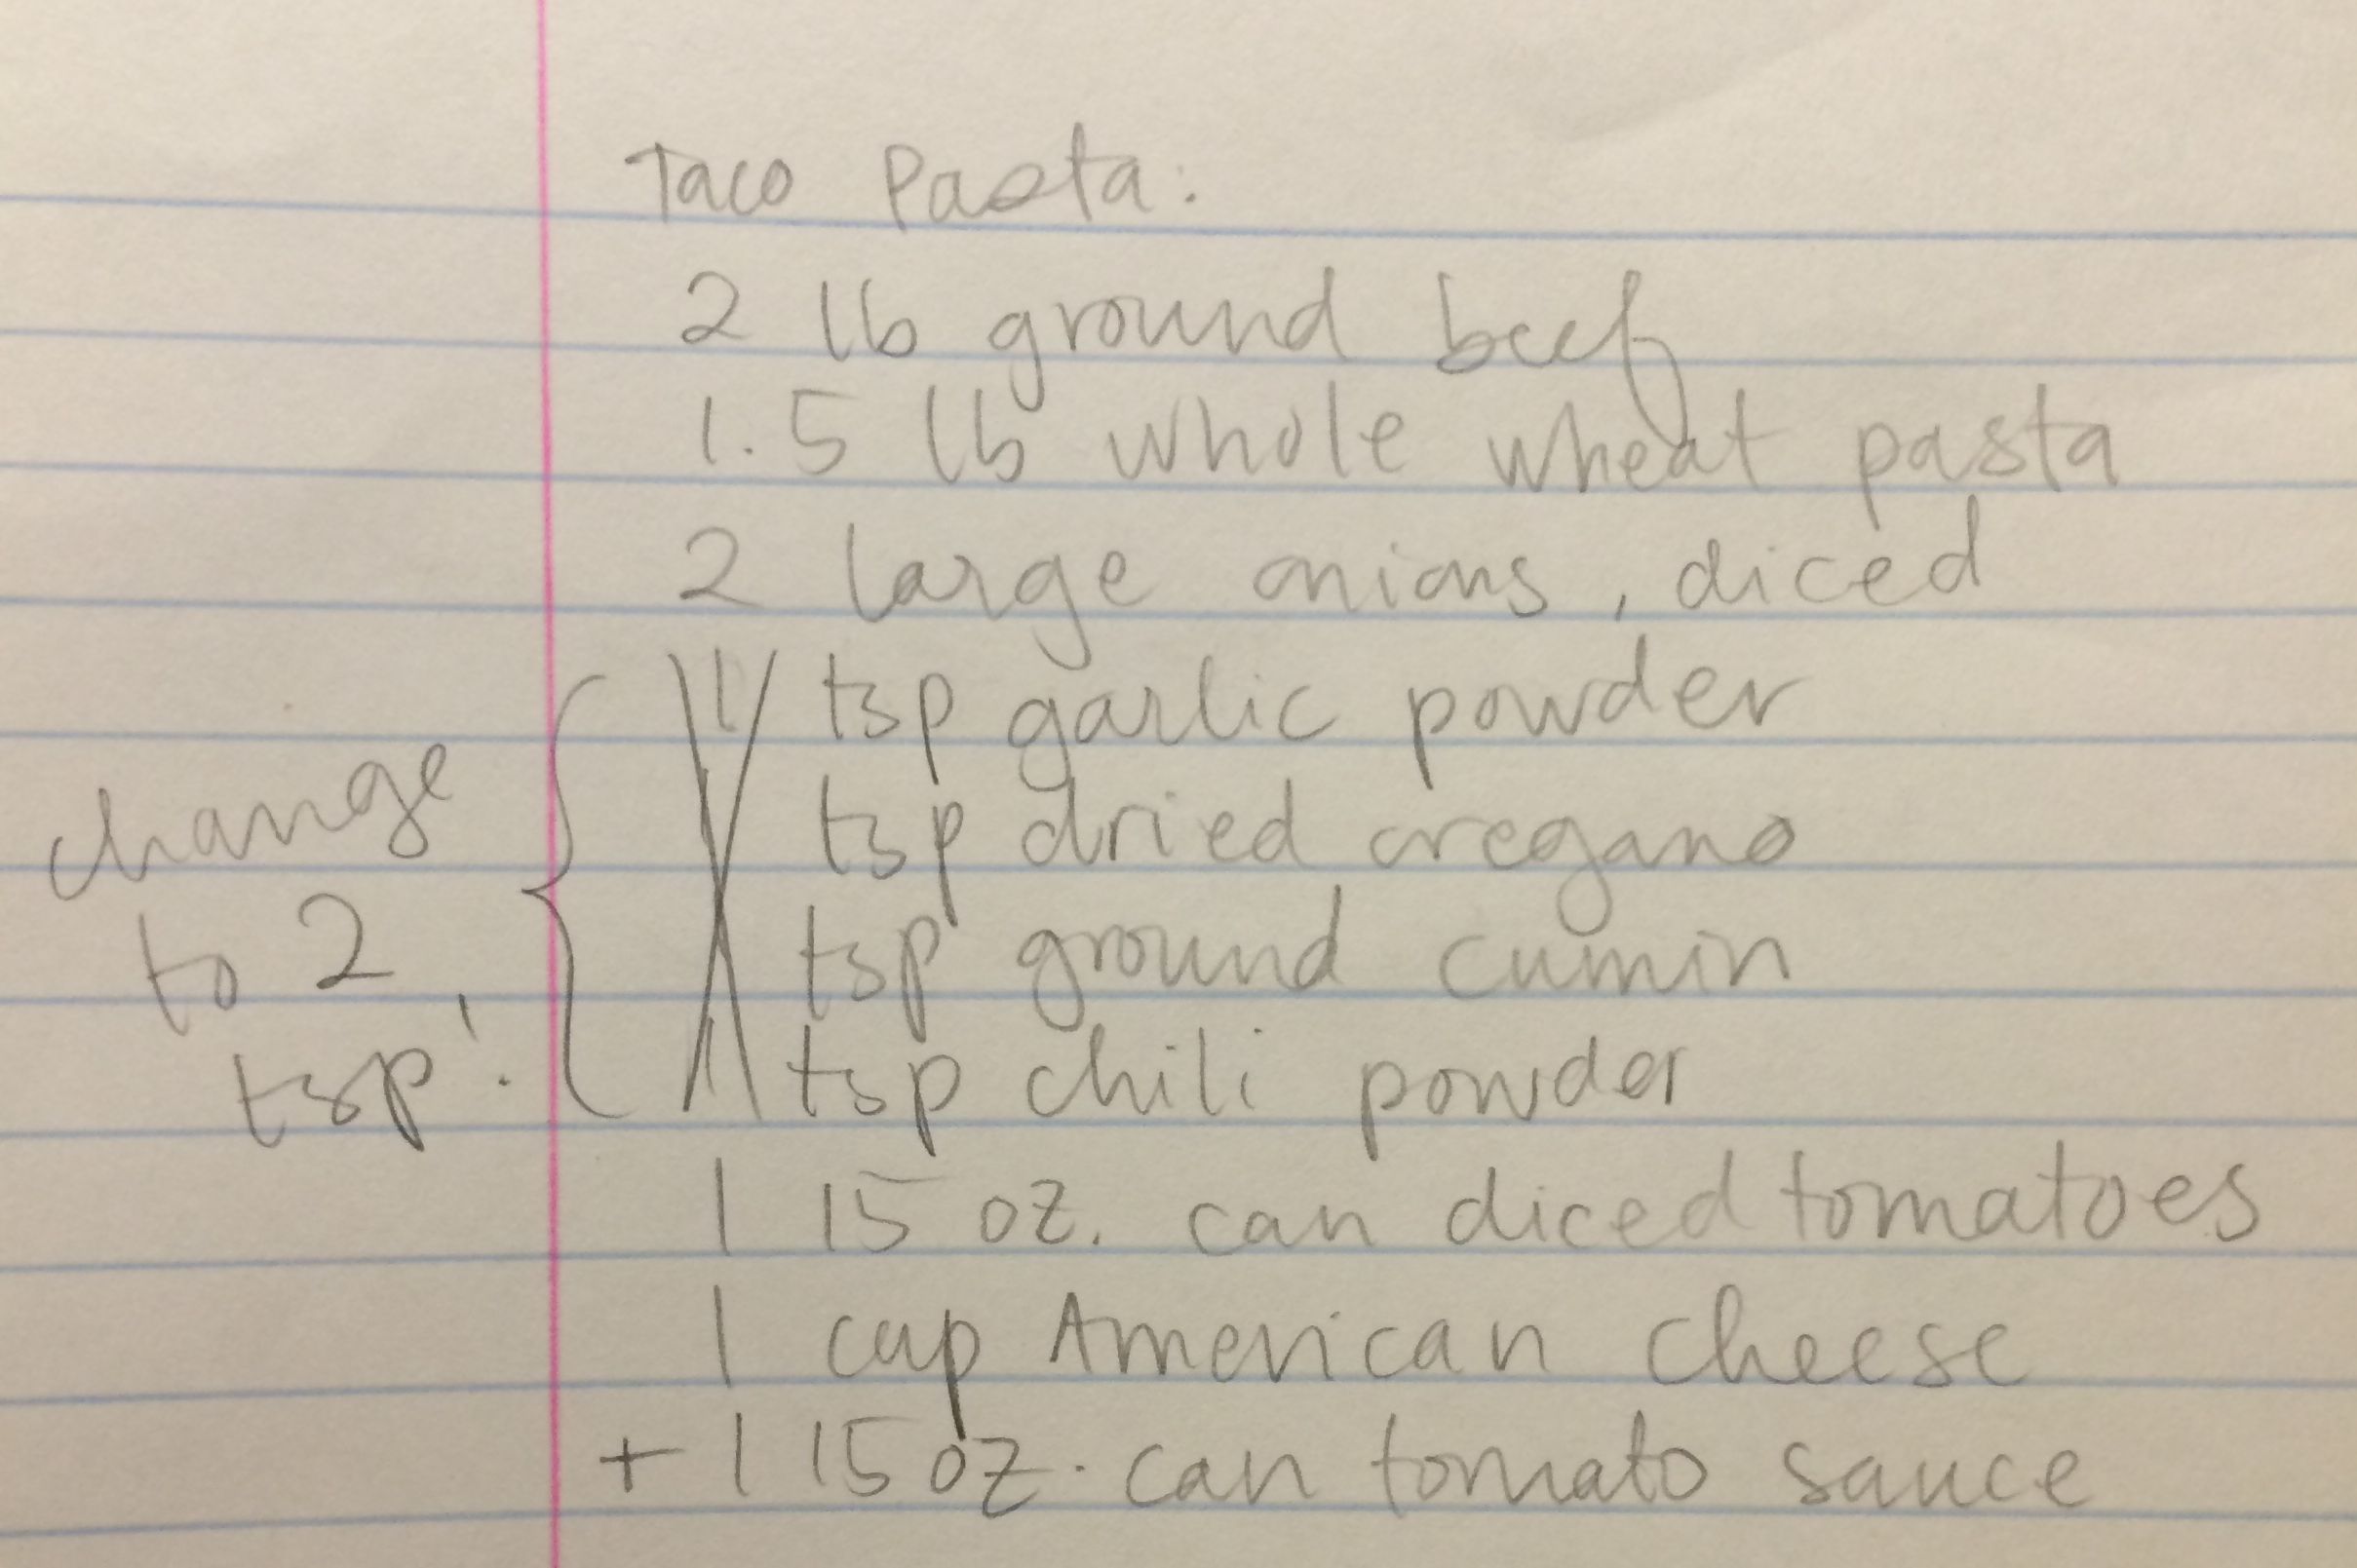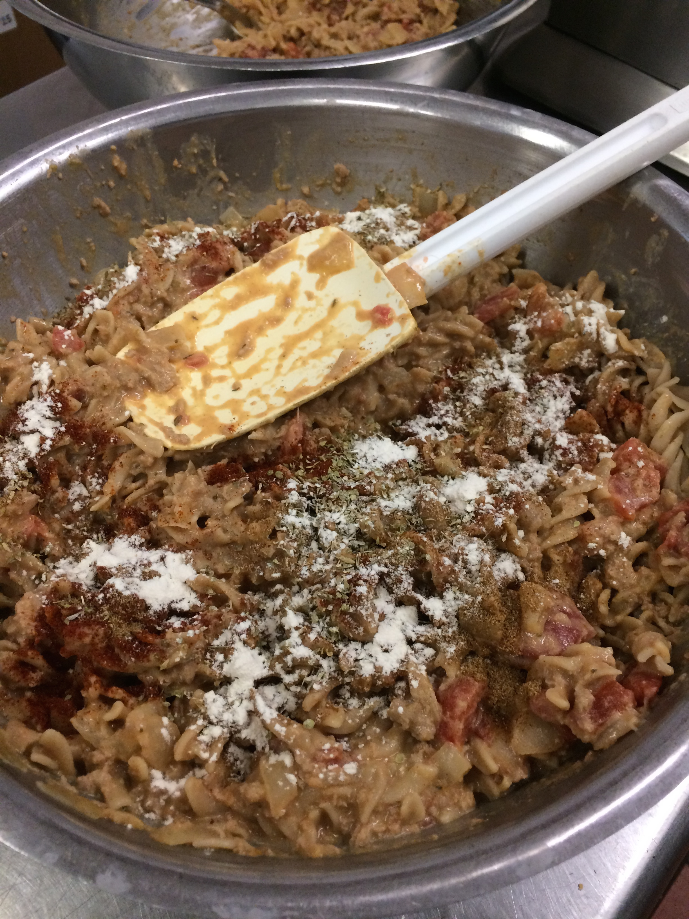
When doubling the recipe to 12 servings, the product was a little bland and not as tasty as the first batch. Irene, Alyssa and I all agreed to add more spices and an extra can of tomato sauce. These additions allowed us to obtain the desired taste.
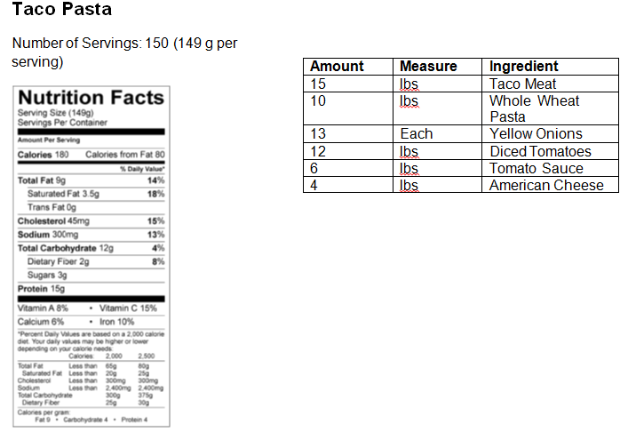
This is the nutrition label we created for the taco pasta. Irene decided to implement taco pasta to her menu so having a nutrition label is essential. It is important for seniors to know the nutritional value of what they’re consuming, especially if they are on a special diet due to illness. Irene usually makes 150 size servings so we also scaled the ingredients appropriately so her team would have no problem making this recipe.

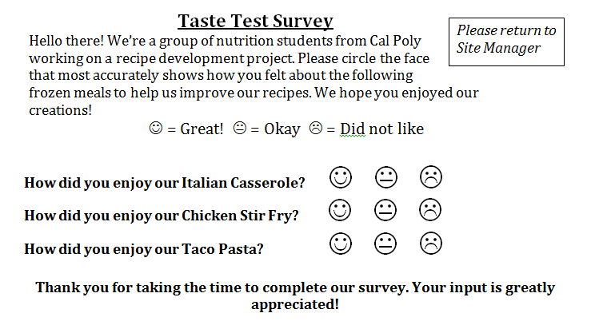
In order to get feedback on our recipe, Alyssa and I created a taste test survey and sent them out to the seniors who tasted our product. Because of time constants, we were unable to get them back in time for the project deadline. However, using informal feedback we learned that the seniors who did report back enjoyed our Taco Pasta. We also had workers and volunteers at the Senior Nutrition Program try the taco pasta and they loved it. Irene, the program manager, was so impressed that she is going to implement the taco pasta to the menu!
